Applied Data Analytics

Assignment 1: On the Fabric Link Dataset

Rohan Karthikeyan

MDS202226

Link 1:

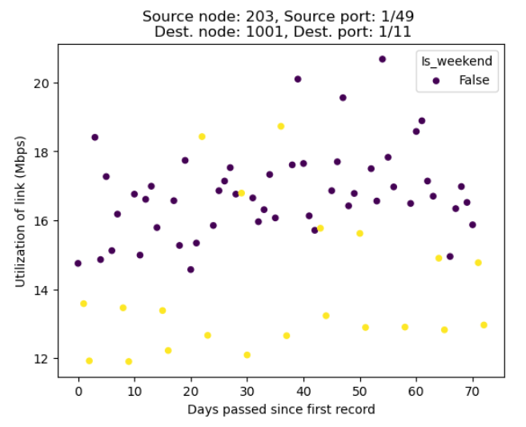

Link 2:

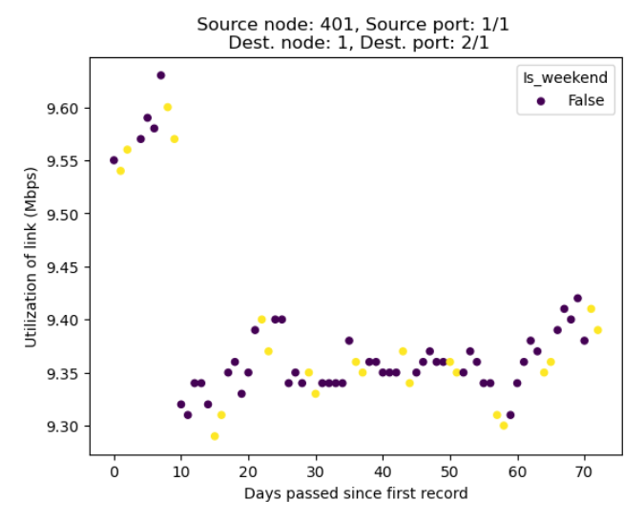

Link 3:

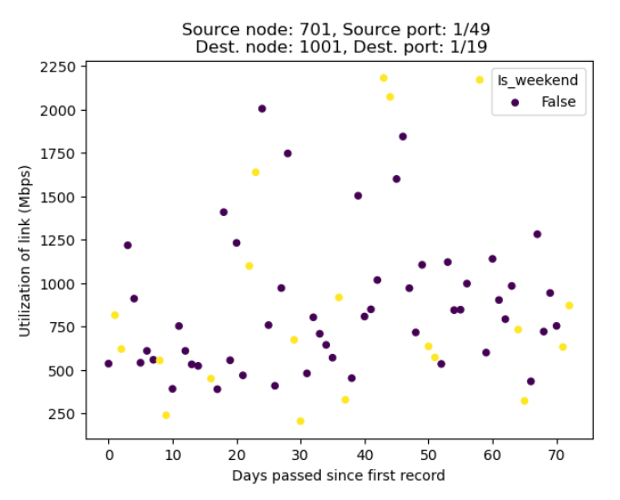

Link 4:

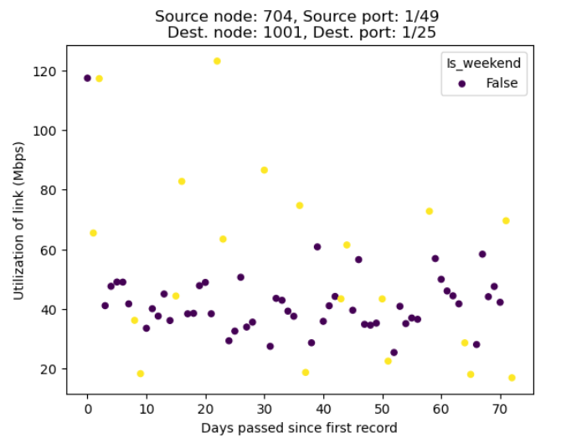

Link 5:

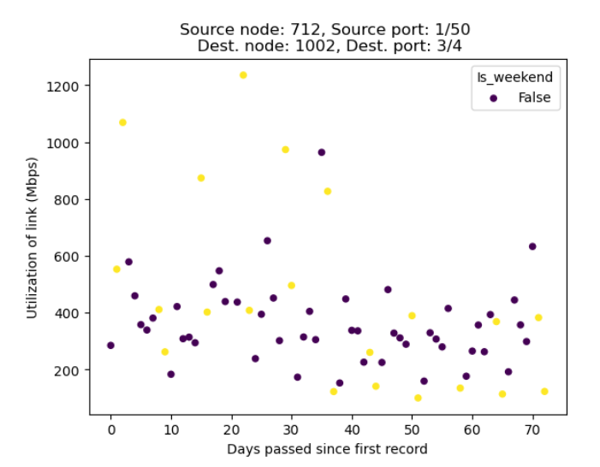

Link 6:

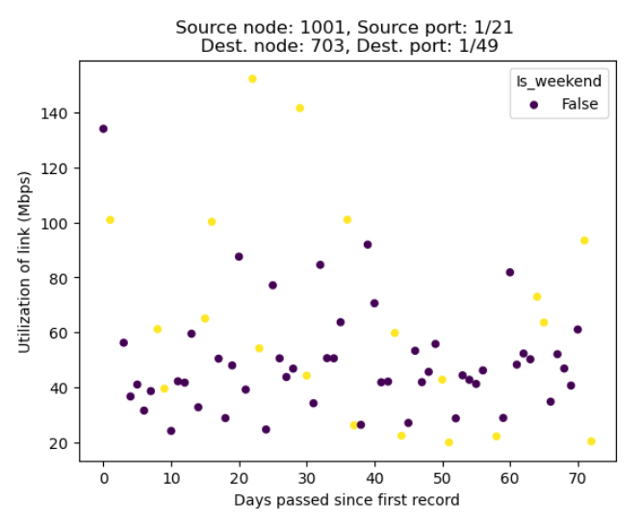

Link 7:

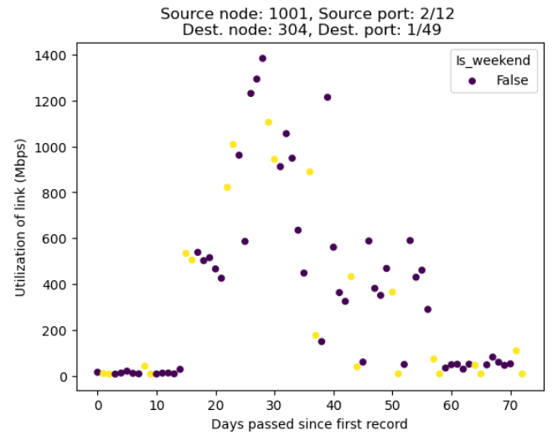

Link 8:

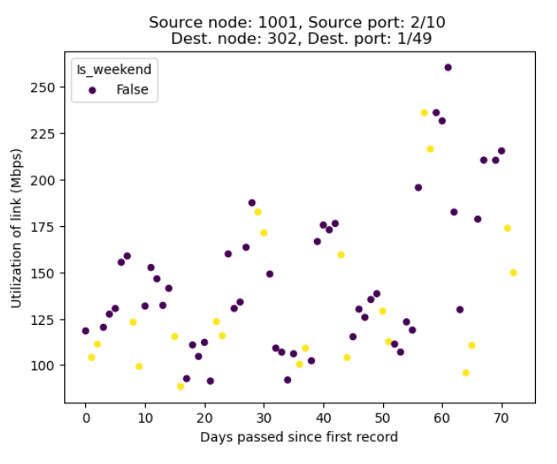

Link 9:

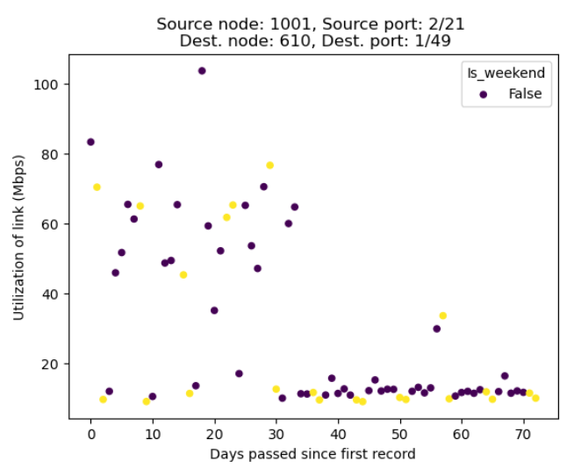

Link 10:

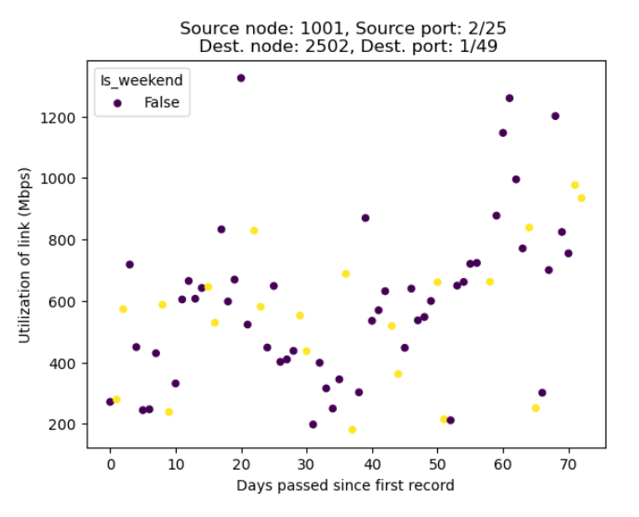

Link 11:

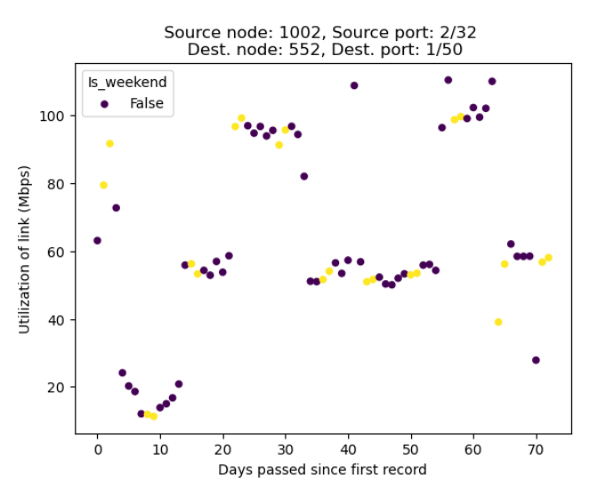

Link 12:

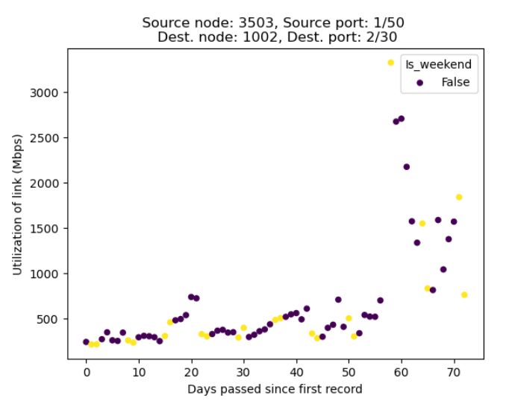

**Inferences**

Q1. Are there any links that show similar patterns?

I feel ***Link 8*** and ***Link 10*** show a similar kind of up-down behavior with an increasing average utilization over time.

There seems to be some sort of visual similarity between ***Link 4***, ***Link 5***, and ***Link 6***. Both ***Link 4*** and ***Link 6*** also share the same scale on the *y*-axis.

Q2. Are there any weekday or weekend patterns?

No, there does not seem to be a striking difference in weekend usages across this random sample.

Q3. What are the inferences that you can draw?

There is no clear pattern in bandwidth utilizations that is shared across links. Some links, for instance, are heavily loaded (e.g., ***Link 3***, ***Link 7***, ***Link 10***) while some links are very lightly loaded (e.g., ***Link 1***, ***Link 2***).

One notes that ***Link 2*** is a link between a leaf node (ID 401) and the controller (ID 1).

I also make some inferences about specific links as follows:

***Link 12***: The sudden spike to above 3000 Mbps utilization is because there is *a missing day* in the data. However, following this incident, all the other days have a utilization higher than before the incident.

***Link 11*** is the only link among this random sample that has multiple runs of tightly clustered (almost constant) utilizations.

***Link 7*** has very low utilizations, before a sudden spike keeps it above 100 Mbps for many days, and then returns to very low values at the end.

***Link 9*** seems to have high values at the start, and then after a month, it never rises above 16 Mbps for the rest of the duration.

Q4. How are the bandwidth utilizations?

They are widely fluctuating. As noted earlier, there is high variability among these random samples in bandwidth utilizations: from a low of 8.5 Mbps (in ***Link 7***) to a high of 2700 Mbps (in ***Link 12***) – accounting for the missing day in ***Link 12***.